Laboratoriya ishi №7

Mavzu: CSS orqali matn va bloklarni bezash

Fan: Web ilovalar

Maqsad: Veb sahifalarda matn elementlari (sarlavha, paragraf, havola) va blok elementlarini (div, section) CSS yordamida turlicha bezash, ularni vizual jihatdan chiroyli ko‘rinishga keltirish.

1. Nazariy qism
CSS (Cascading Style Sheets) — bu veb sahifalarning tashqi ko‘rinishini bezatish uchun ishlatiladigan uslub tili. CSS yordamida matn, fon, ramka, soyalar, o‘lchamlar va joylashuvlarni o‘zgartirish mumkin.

CSS orqali bezashning asosiy usullari:
Matn bezagi:
*color — matn rangi
*font-size — shrift o‘lchami
*font-family — shrift turi
*text-align — matnni joylashtirish (chap, o‘rta, o‘ng)
*text-transform — katta-kichik harflarni boshqarish
*text-shadow — matnga soyalar qo‘shish
Blok bezagi:
*background-color — fon rangi
*border — ramka
*border-radius — burchaklarni yumaloqlash
*box-shadow — blok soyasi
*margin, padding — ichki va tashqi oraliqlar

2. Amaliy qism

Fayl tuzilmasi:
/lab7/
│
├── index.html
└── style.css

index.html
<!DOCTYPE html><html lang="uz"><head>
<meta charset="UTF-8">
<meta name="viewport" content="width=device-width, initial-scale=1.0">
<title>CSS orqali matn va bloklarni bezash</title>
<link rel="stylesheet" href="style.css"></head><body>
<header>
<h1>CSS orqali matn va bloklarni bezash</h1>
</header>

<section class="intro">
<p>
Ushbu sahifada <b>CSS</b> texnologiyasi yordamida matn va blok elementlarini bezash usullarini ko‘rib chiqamiz.
</p>
<a href="#" class="link">Ko‘proq o‘qish →</a>
</section>

<section class="bloklar">
<div class="blok birinchi">
<h2>1-blok</h2>
<p>Oddiy fon va soyali matn namunasi.</p>
</div>

<div class="blok ikkinchi">
<h2>2-blok</h2>
<p>Gradient fon va radiusli chekkalar bilan.</p>
</div>

<div class="blok uchinchi">
<h2>3-blok</h2>
<p>Hover effekti bilan o‘zgaradigan blok.</p>
</div>
</section>

<footer>
<p>&copy; 2025. Web ilovalar fanidan laboratoriya ishi.</p>
</footer></body></html>

3. Natija
*Brauzerda sahifa ochilganda quyidagilar kuzatiladi:
*Sarlavha rangli fon bilan chiqadi.
*Matn markazda joylashgan.
*Uchta blok element turlicha bezatilgan (fon, soya, radius, hover effekti bilan).
*Hover (sichqoncha olib borilganda) effektlar ishlaydi.
Topshiriq: Avto salon sayti

<!DOCTYPE html>
<html lang="uz">
<head>
<meta charset="UTF-8" />
<meta name="viewport" content="width=device-width, initial-scale=1.0" />
<title>Avtosalon</title>
<style>
body {
font-family: Arial, sans-serif;
background-color: #e6f0ff;
margin: 0;
padding: 0;
}
.container {
width: 90%;
margin: 0 auto;
padding: 20px 0;
text-align: center;
}
h1 {
color: #003366;
margin-bottom: 30px;
}
.cards {
display: flex;
justify-content: space-around;
flex-wrap: wrap;
}
.card {
background: white;
width: 240px;
border-radius: 10px;
padding: 15px;
margin: 15px;
box-shadow: 0 4px 8px rgba(0,0,0,0.1);
}
.card img {
width: 100%;
height: 160px;
object-fit: cover;
border-radius: 8px;
}
.card h3 {
margin: 10px 0 5px;
font-size: 18px;
color: #003366;
}
.card p {
margin: 4px 0;
font-size: 14px;
}
</style>
</head>
<body>
<div class="container">
<h1>Brend Avtosalon</h1>

<div class="cards">
<div class="card">
<img src="rasm 1.jpg" alt="Mashina">
<h3>Chevrolet Cobalt</h3>
<p>Narxi: 140 000 000 so'm</p>
<p>Dvigatel: 1.5 Benzin</p>
</div>

<div class="card">
<img src="rasm 2.jpg" alt="Mashina">
<h3>Chevrolet Malibu</h3>
<p>Narxi: 320 000 000 so'm</p>
<p>Dvigatel: 2.0 Turbo</p>
</div>

<div class="card">
<img src="rasm 3.jpg" alt="Mashina">
<h3>Chevrolet Tracker</h3>
<p>Narxi: 260 000 000 so'm</p>
<p>Dvigatel: 1.2 Turbo</p>
</div>

<div class="card">
<img src="rasm 4.jpg" alt="Mashina">
<h3>Chevrolet Equinox</h3>
<p>Narxi: 420 000 000 so'm</p>
<p>Dvigatel: 1.5 Turbo</p>
</div>

<div class="card">
<img src="rasim 5.jpg" alt="Mashina">
<h3>Chevrolet Tahoe</h3>
<p>Narxi: 850 000 000 so'm</p>
<p>Dvigatel: 5.3 V8</p>
</div>
</div>
</div>
</body>
</html>

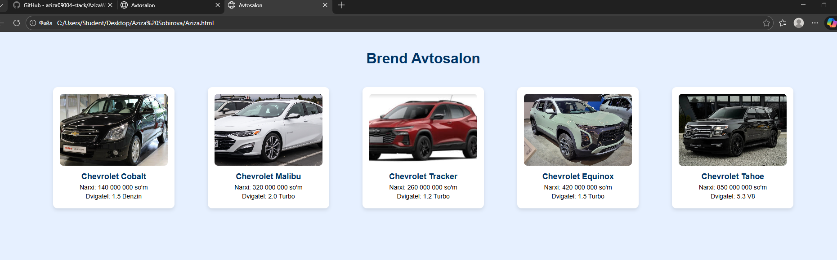

4. Xulosa
Ushbu laboratoriya ishida CSS yordamida matn va blok elementlarini bezash usullari amalda qo‘llandi.
Natijada, foydalanuvchiga estetik jihatdan yoqimli va qulay interfeys yaratish imkoniyati hosil bo‘ldi. CSS web-sahifani dizaynerlik jihatidan boyitadi va struktura (HTML) bilan uslub (CSS)ni ajratishga yordam beradi.

